2025
Gordon Elliott Williams, P10026108
BIA550-30 BUSINESS INTELLIGENCE AND ANALYTIC SYSTEMS – POST UNIVERSITY
6/6/2025
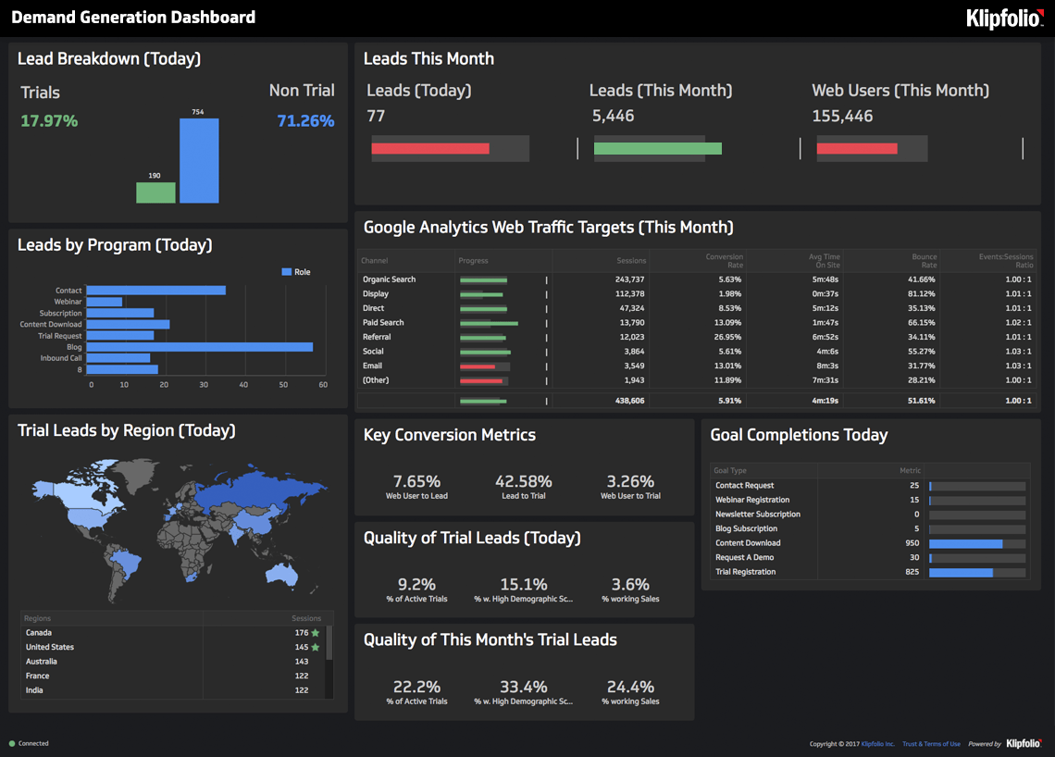
The Crucial Role of Interactivity and User Experience in Dashboard Design
In today's data-driven world, dashboards have evolved beyond simple data displays to become indispensable tools for informed decision-making. No longer sufficient are static reports that merely present figures; instead, the emphasis has shifted dramatically towards dynamic, interactive platforms that empower users to explore, analyze, and derive insights from complex datasets. This evolution underscores the paramount importance of both interactivity and user experience (UX) in effective dashboard design. As I reflect on the challenges and opportunities in this field, I firmly believe that the success of any dashboard hinges on its ability to engage users and provide them with an intuitive pathway to actionable intelligence.
The Imperative of Interactivity and User Experience
At its core, a dashboard aims to simplify complex information, allowing users to grasp key trends and make timely decisions. Without robust interactivity and a well-thought-out user experience, even the most meticulously gathered data can remain inaccessible and underutilized.
Interactivity transforms a static report into a conversational tool. Instead of simply presenting data, an interactive dashboard allows users to ask questions of the data itself. This might involve filtering data by specific categories (e.g., region, product, time period), drilling down into granular details from a high-level summary, or even comparing different metrics side-by-side. This active engagement fosters a deeper understanding and enables users to uncover insights that might otherwise remain hidden. For instance, imagine a sales manager looking at overall revenue. A static report would show the total, but an interactive dashboard allows them to filter by individual sales representatives, product lines, or even specific customer segments, instantly revealing performance variations and areas for improvement. This ability to manipulate and investigate the data on demand is what makes a dashboard truly valuable.
Coupled with interactivity, a superior user experience ensures that these powerful features are not just present but also intuitive and easy to use. UX in dashboard design encompasses clarity, consistency, visual hierarchy, and performance. A dashboard with good UX is not cluttered; it prioritizes information, guiding the user's eye to the most critical metrics first. Colors are used purposefully to highlight insights, not distract. Navigation is logical, and the interface responds quickly to user actions. When a dashboard is designed with the user's needs and cognitive load in mind, it reduces frustration, enhances comprehension, and encourages continuous exploration, ultimately speeding up decision-making (Flick, 2025). As I've observed in various projects, if users struggle to find information or understand how to interact with the dashboard, they will quickly abandon it, regardless of the quality of the underlying data.
Hallmarks of Effective Dashboards and Their Features
Effective dashboards are distinguished by several key features that facilitate both interactivity and a positive user experience. Here is a description of what makes them successful:
- Clear Information Hierarchy: The most critical KPIs (Key Performance Indicators) are prominently displayed, often at the top or left, drawing immediate attention. Supporting details are then organized logically, using visual cues like size, color, and positioning to guide the user's eye.
  - Example: A financial dashboard might show "Total Revenue," "Net Profit," and "Operating Expenses" as large, bold numbers at the top, perhaps with color-coded indicators (green for positive trends, red for negative). Detailed breakdowns by quarter or department would then follow below.
- Intuitive Filters and Slicers: These allow users to narrow down the displayed data based on various dimensions (e.g., date ranges, geographical locations, product categories, customer types). They are typically presented as drop-down menus, sliders, checkboxes, or search bars that are easy to locate and operate.
  - Example: A marketing dashboard might have filters for "Campaign Type" (e.g., 'Email', 'Social Media', 'PPC'), "Region," and "Date Range," allowing a marketing manager to analyze the performance of specific initiatives.
- Drill-Down Capabilities: This feature enables users to click on a high-level data point (e.g., a bar in a chart representing overall sales) and dive deeper into its constituent parts (e.g., sales by individual product, by region, or by sales representative). This provides a seamless transition from summary to detail.
  - Example: In a customer service dashboard, clicking on a "High Priority Tickets" segment of a pie chart might open a new view or table listing all individual high-priority tickets, including their status, assigned agent, and time open.
- Customizable Views: Advanced dashboards offer personalization options, allowing users to arrange widgets, choose preferred visualizations, or save custom views. This caters to diverse user needs and preferences, making the dashboard more relevant to individual roles.
  - Example: An executive might want a high-level strategic overview, while a department manager might need an operational dashboard with more granular details. A customizable feature allows each to tailor their primary view.
- Interactive Visualizations: Charts and graphs are not just static images. Hover-over tooltips provide additional details on data points without cluttering the main view. Clicking on a legend item might filter the entire dashboard to show only data related to that category.
  - Example: A line chart showing website traffic might display the exact number of visitors and the date when hovering over a specific point, and clicking a specific traffic source in the legend might update other charts to show only data for that source.
- Responsiveness: Effective dashboards are designed to adapt seamlessly across different devices and screen sizes, from desktop monitors to tablets and smartphones. This ensures accessibility and usability on the go.
Dashboards Adapting to Business Nature
Dashboards are not one-size-fits-all solutions; their design, metrics, and interactivity features must be tailored to the specific nature of the business, its objectives, and its target audience. The type of data collected, the key decisions that need to be made, and the roles of the users all influence dashboard design.
Let's consider a few examples:
- Sales Dashboard:
  - Key Metrics: Focus on revenue (actual vs. target), sales growth, lead conversion rates, average deal size, sales cycle length, and individual sales representative performance.
  - 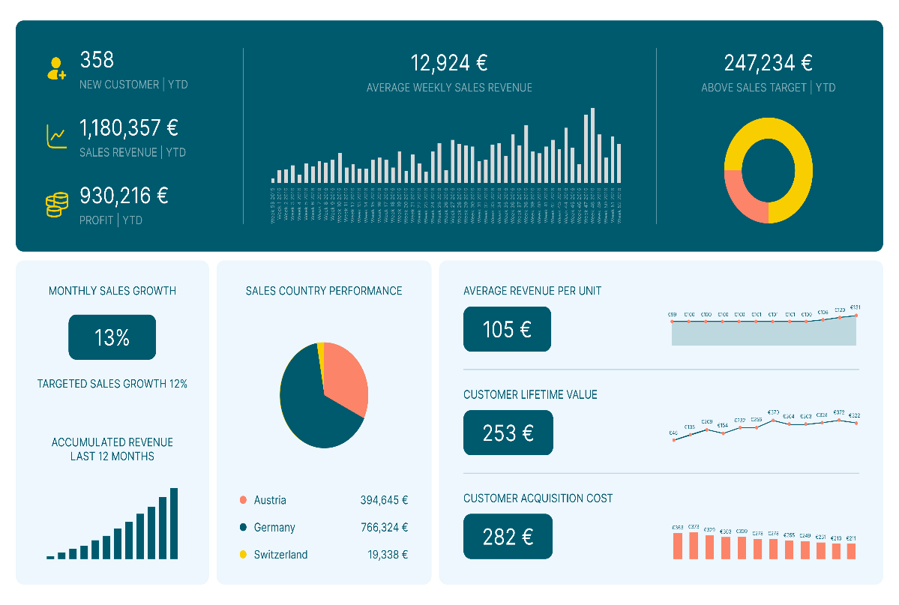
    - https://voiptimecloud.com/blog/sales-dashboard
  - Interactivity: Filters for sales region, product line, customer segment, and time period are crucial. Drill-downs into individual deals or sales calls are common. A sales manager needs to quickly identify top performers, underperforming regions, or products that aren't meeting targets. For instance, a sales manager would frequently use filters to see "Sales by Product Category in Q2, North America" or "Individual Rep Performance for Enterprise Accounts." The goal is to drive immediate action to improve sales performance (GoodData, 2025).
- Financial Dashboard:
  - Key Metrics: Emphasize profitability, cash flow, expenses, budget vs. actuals, accounts receivable/payable, and key financial ratios. Accuracy and context are paramount.
  - 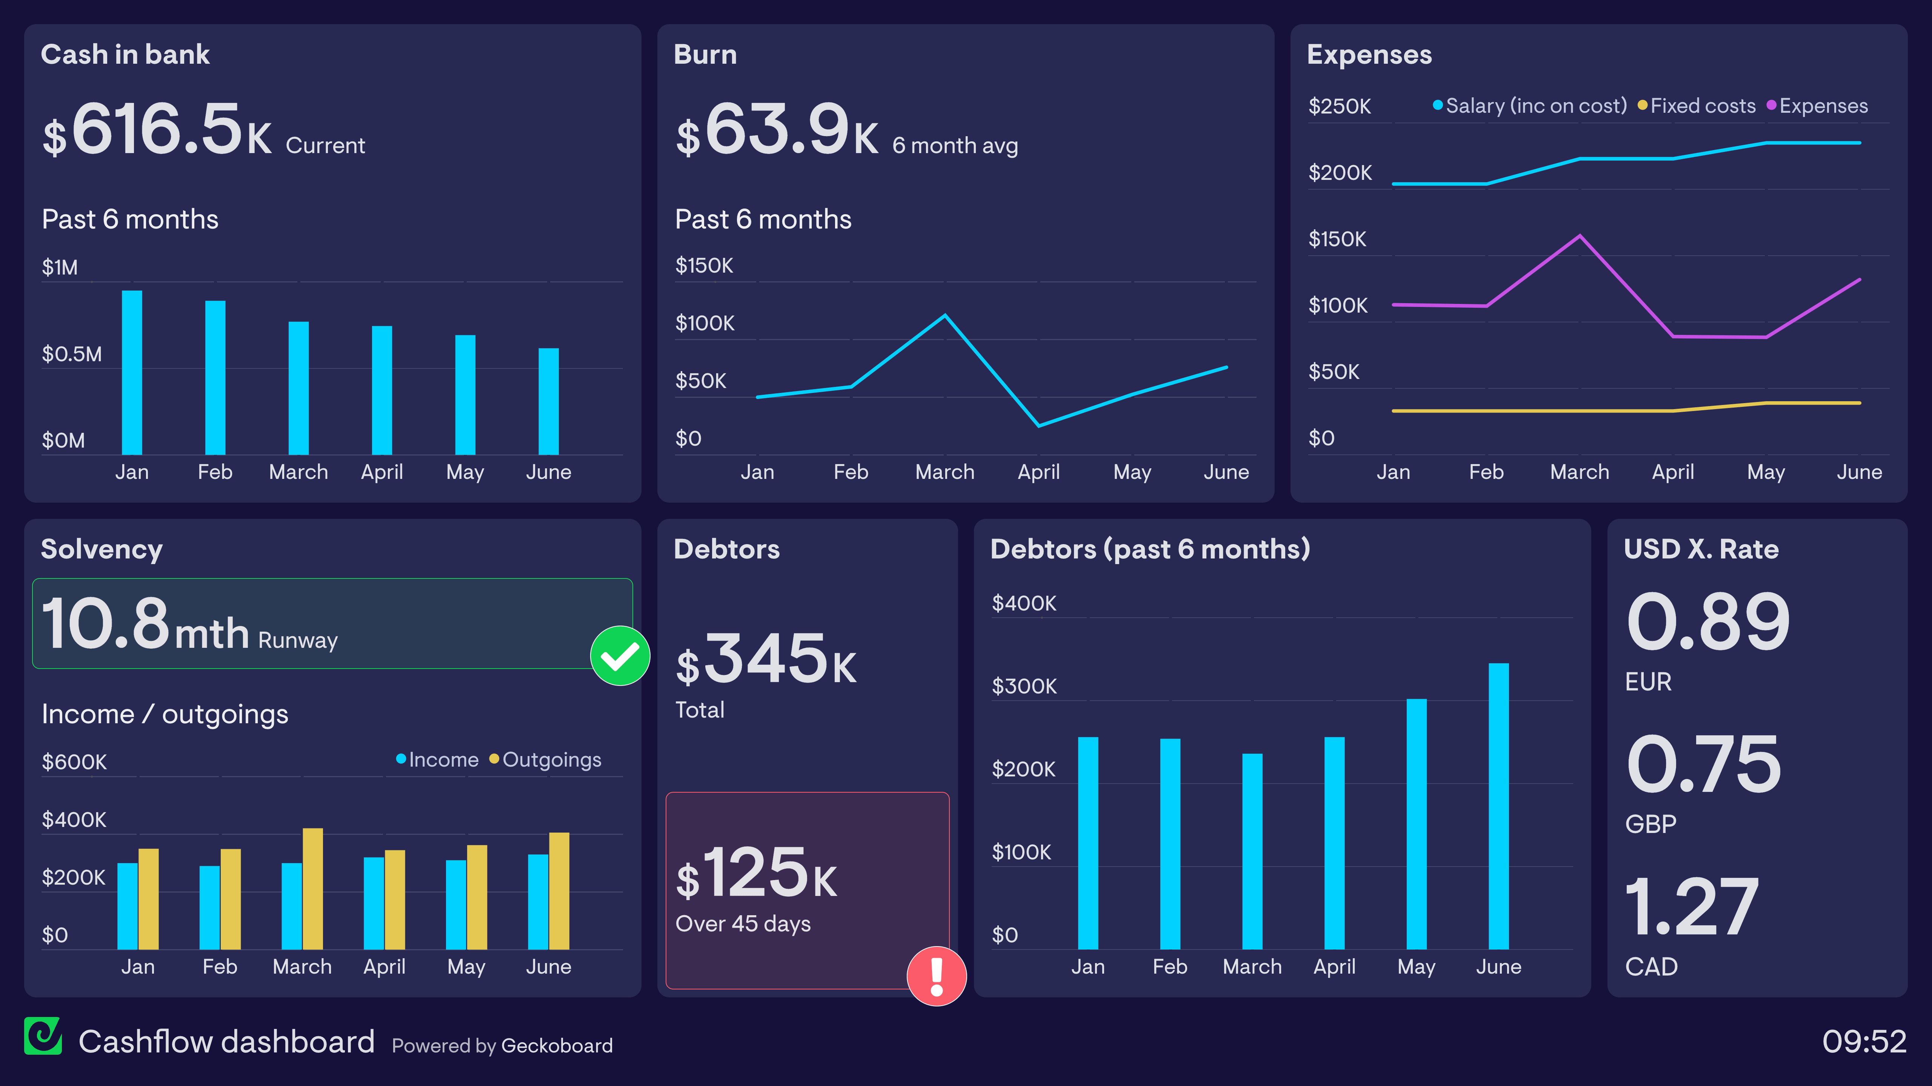
    - https://www.geckoboard.com/dashboard-examples/finance/
  - Interactivity: Filters by department, cost center, time period (e.g., fiscal year, quarter, month), and account type are essential. Drill-downs often lead to detailed transaction reports or ledger entries. Financial dashboards need to be precise and provide the context for numbers, often including comparisons to previous periods or budgets (ClicData, 2025). The CFO needs to quickly assess the company's financial health, identify areas of overspending, or track investment returns.
- Healthcare Dashboard:
  - Key Metrics: Focus on patient outcomes, readmission rates, hospital bed occupancy, patient wait times, medication adherence, staff-to-patient ratios, and operational efficiency. Data privacy (HIPAA compliance) is critical.

  - 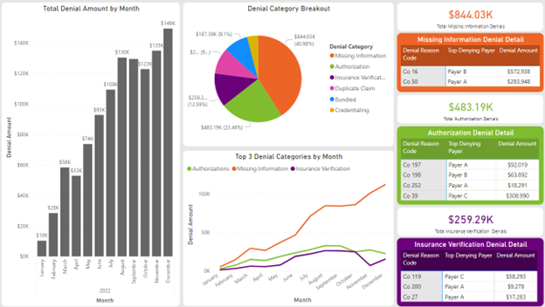

    - https://www.rccsinc.com/newsroom/top-3-healthcare-dashboards-for-providers
  - Interactivity: Filters by patient demographics, diagnosis, department, and physician. Drill-downs might show individual patient records (with appropriate access controls) or detailed procedure logs. Healthcare dashboards are designed to improve patient care and operational efficiency, often requiring real-time updates and clear, actionable insights for medical professionals (Sidekick Interactive, 2025). For example, a hospital administrator might monitor bed occupancy rates by ward and filter by patient severity to manage resources effectively.
- Marketing Analytics Dashboard:
  - Key Metrics: Concentrate on website traffic, lead generation, conversion rates, campaign ROI, customer acquisition cost (CAC), social media engagement, and email marketing performance.
  - 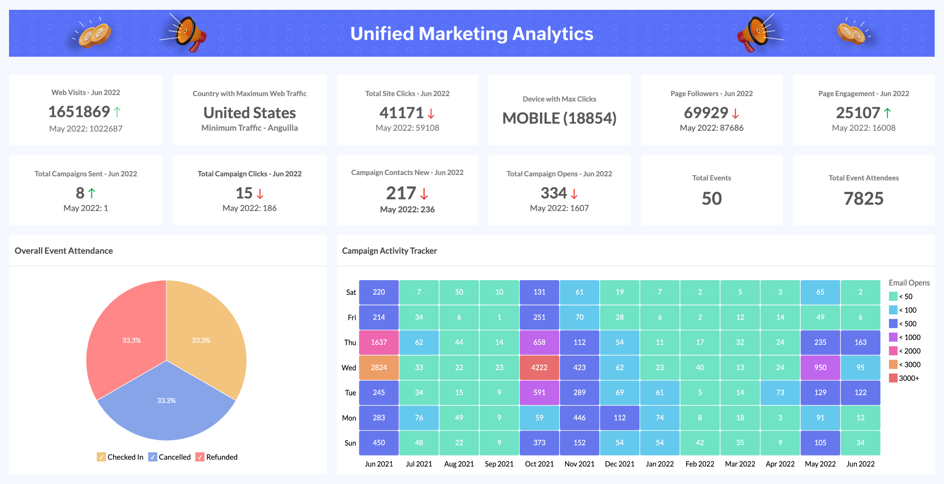
    - https://www.zoho.com/analytics/marketing-dashboard.html
  - Interactivity: Filters for marketing channel (e.g., SEO, SEM, social, email), campaign name, geographic audience, and specific landing pages. Drill-downs allow analysis of individual ad performance or website visitor paths. Marketing dashboards are dynamic, often integrating data from multiple platforms (Google Analytics, social media, CRM) to provide a holistic view of marketing effectiveness and guide future campaigns (Domo, 2025). A digital marketing specialist would constantly use filters to compare the performance of different ad campaigns or to see how a specific landing page converts visitors.
These examples illustrate that while the underlying principles of good UX and interactivity remain constant, their application and the specific features prioritized will vary significantly based on the domain.
Dashboard Interactivity for End Users
The ultimate goal of dashboard interactivity is to empower end users to become self-sufficient data explorers, reducing their reliance on data analysts for every query. This is how I envision end users interacting with and extracting necessary data from a well-designed dashboard:
- Initial Overview and High-Level Insights: Upon opening the dashboard, the user immediately sees the most important KPIs and high-level summaries. This initial view acts as a "single pane of glass," providing an instant snapshot of performance. For instance, a CEO might see overall company revenue, profit margins, and customer growth trends.
- Filtering for Context: If the user wants to understand how these high-level metrics change for a specific segment, they use filters. A sales director, for example, might apply a filter to view sales data only for the "West Coast" region or for "Q3." This customizes the entire dashboard to their specific area of interest.
- Drilling Down for Detail: When a particular trend or anomaly catches their eye, the user can click on the relevant visual element (e.g., a bar on a chart, a number in a table) to drill down. This action reveals the underlying data that contributes to that summary. For instance, clicking on "Q3 West Coast Sales" might show a breakdown of sales by individual products sold in that region during that quarter. This iterative process allows for deep dives into specific areas without overwhelming the user with all data at once.
- Comparing and Contrasting: Users can leverage interactive elements to compare different datasets or time periods. This might involve selecting multiple product lines to compare their growth rates on a line chart, or toggling between "Current Year" and "Previous Year" data views.
- Exporting and Sharing: While interaction within the dashboard is key, users often need to export specific filtered views or underlying data for further analysis in other tools, or to share insights with colleagues who may not have direct dashboard access. Effective dashboards provide options to export data (e.g., CSV, Excel) or even share a permalink to their current filtered view.
- Personalization and Customization: For regular users, the ability to save personalized layouts or frequently used filter combinations significantly enhances their experience. This means the dashboard adapts to their workflow, not the other way around.
Application to My Final Group Project
Considering the importance of interactivity and UX in dashboard design, my final group project, which focuses on developing a "Smart Campus Energy Management System," will critically apply these principles. The project's success hinges on providing various stakeholders – from facility managers and university administrators to students and researchers – with actionable insights into energy consumption patterns.
For this project, our dashboard will feature a prominent overview displaying real-time energy consumption across the entire campus, perhaps with a clear visual indicating whether current usage is above or below target. This high-level view will be crucial for administrators to quickly assess overall sustainability efforts.
The interactive elements will be paramount. Facility managers, for instance, will require the ability to filter energy data by specific buildings, floors, or even individual rooms to identify areas of excessive consumption. They will need drill-down capabilities to investigate anomalous spikes in usage, potentially revealing faulty equipment or behavioral issues. Imagine a facility manager clicking on a particular building experiencing high energy consumption to see a detailed breakdown by HVAC, lighting, and plug loads, and then further drilling down to hourly consumption patterns to pinpoint when the inefficiency occurred.
We will incorporate comparative analysis features, allowing users to compare the energy performance of similar buildings or track progress against historical benchmarks or sustainability goals. For researchers, the ability to export filtered datasets for in-depth statistical analysis will be a critical interactive feature.
From a UX perspective, we will prioritize a clean, intuitive layout with a consistent color scheme that clearly differentiates energy sources or consumption levels. Key performance indicators like "Energy Savings Percentage" or "Carbon Footprint Reduction" will be visually prominent. We will ensure the dashboard is mobile-responsive, allowing facility staff to access critical data on the go using tablets or smartphones. The goal is to provide a seamless and engaging experience that encourages proactive energy management and fosters a culture of sustainability across the campus.
By meticulously designing for interactivity and user experience, we aim to create a dashboard that not only presents data but actively empowers users to understand, analyze, and ultimately reduce energy consumption on our smart campus, contributing to a more sustainable future.

References
ClicData. (2025, March 10). 16 techniques to make your data dashboards user-friendly and interactive. Retrieved from https://www.clicdata.com/blog/why-user-friendly-and-interactive-data-dashboards-matter/
Domo. (2025, January 3). Dashboard design: Examples, layouts, and best practices. Retrieved from https://www.domo.com/learn/article/dashboard-design-examples-best-practices
Flick, T. (2025, May 9). Best practices for dashboard UI/UX to enhance user experience. ResearchGate. Retrieved from https://www.researchgate.net/publication/391574128_Best_Practices_for_Dashboard_UIUX_to_Enhance_User_Experience
GoodData. (2025, March 13). 8 essential sales dashboard examples for revenue growth. Retrieved from https://www.gooddata.com/blog/sales-dashboard-examples/
Sidekick Interactive. (n.d.). UX/UI best practices for healthcare analytics dashboards. Retrieved from https://www.sidekickinteractive.com/designing-your-app/uxui-best-practices-for-healthcare-analytics-dashboards/

